Army Shooter

# game mechanics

Top down shooter, the aim of the game to for the player to explore the level and defeat all the enemies.

There will be obstacles such as water and walls and enemies will come as singular or groups.

When all the enemies are defeated the boss will spawn, once the boss is defeated onto the next level.

We are hopeful to have a level each as we are a 3 man team and we are using GitHub and Trello to exchange ideas / update code.

Player Functions

* Player will have health and when the player collides with enemies or lava, the health will diminish and player will die. The player will have Ammunition, and a reload time. And cooldown timer for grenades.

L:\Assessment 3\grenade.png Player will also have the ability to throw a grenade to damage multiple enemies, with a cooldown timer, so the player can’t simply spam it.

**If we have time we will try to upgrade the player reload time, ammunition, movement speed etc with a currency or score. Ammo will be found around the level, or maybe a drop chance from enemies.**

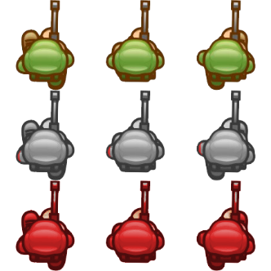

Enemy Functions

Enemy will simply wonder around randomly pausing and choosing random directions and will agro towards the player after they have been hit or the player gets too close to the enemy.

The enemy will have attacking animation that will do damage to player health.

Upon death, the enemy will add to the players score and check if there are any more left and spawn the boss if necessary.

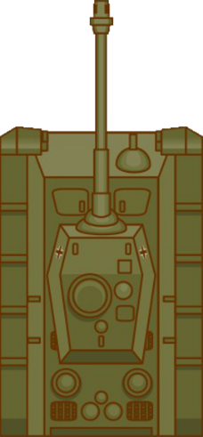

Boss Functions

Bosses will be more challenging and harder to kill then the trash mobs. Bosses are the gateway to the next level, and will have more hp and do more damage to the player then 3 or more enemies would do. The bullets anfd the grenades will reduce the health of the boss until eventually it is dead.

Keys / Buttons

WASD or Arrow Keys to move the player.

Button num 1 to shoot bullets.

Button num 2 to throw grenade.

Target Audience

Top down shooters, older school retro gamers, indie gamers.

Rough Flow Chart

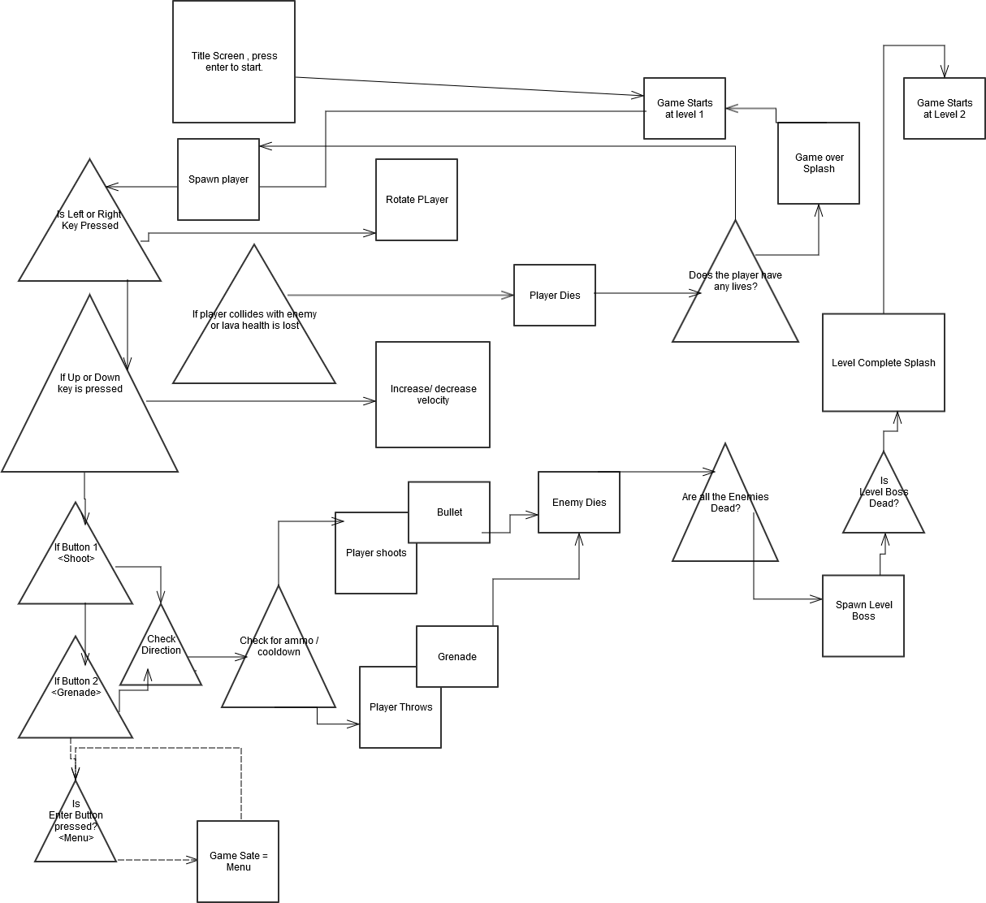

|  |
| --- |
|  |

Rough Schedule

